Affective Unit: Bibliotherapy and Art Therapy Peter Reynolds

Margaret Tyner

Troy University

Teaching Methods in Gifted Education

EDG6669

|  |  |  |  |
| --- | --- | --- | --- |
| **Affective Unit: Bibliotherapy/Art Therapy**  **Using the Work of Peter Reynolds** | | | |
| Conceptual Lens (Big Idea): **Communication, Interpretation, Choice** | | | |
| Target Grades: 1 – 3 | | | |
| **Rationale for the Unit:** In this bibliotherapy/art therapy unit, students read stories by Peter Reynolds to explore affective challenges gifted children face. Because of asynchronous development, young gifted children often develop feelings perfectionism and poor self-concept. Young children in primary school may be heard saying, “I can’t draw.” Without creative opportunities, gifted children will experience a creativity slump by the time they are in fourth grade. Peter Reynolds’s books provide children with opportunities to develop confidence and creativity. Through reading, discussion, and artistic experiences, children develop the willingness to take risks and become self-actualizing. Incorporating art into the elementary classroom provides a way for young children to express their feelings, even when they may not be able to express them verbally (Karnes & Bean, 2009) | | | |
| **Critical Content** | | | |
| **Goals**  **The students will …** | **Process Skills**  **The students will be able to…** | | **Supporting Concepts** |
| * Define key terms related to interest, creativity, perfectionism, and emotion * Observe problems from different points of view * Accept mistakes as opportunities to learn * Explain how to employ strategies to stick with tasks until they are completed * Examine feelings and intuition as important as reason and logic * Evaluate how fantasy and reflection are valuable tools for learning and creative development | * Apply visual thinking and creative strategies * Express opinions with reasoning to support them * Interpreting points of view * Develop a personal plan for increasing creative development * Design, create, and evaluate works of art * Express feelings visually, orally, and in writing * Difference between reality and fantasy * Seven art elements – line, shape, color, value, texture, form, and space * Respond to artwork on an emotional level | | * Components of creative thinking: fluency, flexibility, originality, and elaboration * Bloom’s Taxonomy * Krathwohl’s Affective Taxonomy * Interpersonal and Intrapersonal components of Gardner’s Multiple Intelligences |
| **Vocabulary** | | **Disciplines** |
| * Creativity * Personality * Influence * Aesthetic | * Emotion * Imagination * Perspective * Abstract & Realism | * Artist * Art Critic * Counselor |
| **Essential Understandings/Generalizations** | | | | |
| 1. **Using artistic elements improves self-expression and communication of ideas.** 2. **Art is a way to express feelings.** 3. **The people who observe artwork see it differently.** | | | | |
| **Essential Questions** | | | | |
| 1. How do artistic elements improve self-expression and communication of ideas? 2. How does art express feeling? 3. Why do people see artwork differently? | | | | |

|  |  |
| --- | --- |
| **Alabama Course of Study Standards** | |
| 1. Articulate feelings of competence and confidence as learners (A:A1.1). 2. Accept mistakes as essential to the learning process (A:A1.4). 3. Demonstrate how effort and persistence positively affect learning (A:A2.2). 4. Demonstrate dependability, productivity and initiative (A:A3.4). 5. Demonstrate the motivation to achieve individual potential (A:B1.1). 6. Describe moods, feelings, and emotions depicted by a work of art (ALCOS 1.5). 7. Express ideas, feelings, and moods in creating works of art. (ALCOS 2.3) 8. Relate moods, feelings, and emotions generated by a work of art to life experiences (ALCOS 2.6). 9. Create symbolic works of art to communicate ideas (ALCOS 3.4) 10. Identify symbols and signs depicting specific ideas, moods, feelings, and emotions generated by a work of art (ALCOS 3.7). 11. Identify ideas and feelings expressed by individual artists in works of art (ALCOS 3.8) | |
| **Class Activities/Lesson Plans/Evaluation** | |
| **Lesson 1 – Dot by Peter Reynolds**  **Main Character, Vashti, thinks she cannot draw. Her teacher demonstrates the worth of Vashti’s work by hanging her picture, of a dot, above her desk. Vashti’s confidence grows, and she in turn gives affirmation to another child who suffers from low self-esteem.** | |
| Advanced Objectives: 1. Define key phrases and words related to interest and creativity: fluency, flexibility, originality, and elaboration.  Phrases from the story, Dot:  “Glued to her chair”, “Just make a mark”,  “See where it takes you”, “Set to work”  “Her artwork made a splash”  2. When asked, “How do feelings motivate you to work on something?” students will examine multiple points of view by brainstorming with post-its and categorizing the responses into two or three categories.  3. When given drawing materials, students will illustrate the their own ideas, patterns found in a variety of items, and inspiration from the book. Following the drawing activity, hang the pictures for children to create a list of ideas to evaluate their artwork.  Time for lesson: Two thirty minute segments  Resources:   1. Dot by Peter Reynolds 2. How to Teach Art to Children | Activity:   1. Write three things you can do very well. 2. How many of those things do you think are interesting? (Turn and Talk) 3. Read The Dot by Peter Reynolds 4. Discuss how the main character, Vashti, changes in the story. Have children write about why she changed. 5. Show children about the elements of line, shape, space and texture (recall some of the dot drawings in the book). 6. Children will create their own dot drawing. 7. Guide children to establish criteria for deciding the aesthetics and originality of the drawings.   Materials:   1. Paper 2. Colored Pencils, tempera paints, pastels, crayons 3. Sharpie Pens 4. Paint brushes |
| Evaluation – Once students finish their dot drawings, they will collaboratively create a self-evaluation of at least 10 requirements. Students will evaluate their own drawings using their checklist. Students must be able to check at least half of the items on their list to score at a proficient level. | |

|  |  |
| --- | --- |
| **Lesson 2 – Ish by Peter Reynolds**  **The main character Ramon loves to draw until his older brother makes fun of his drawing. He loses his confidence and gives up drawing. His younger sister shows him that his drawings may not look exactly like the item he was trying to depict; however, they are “ish” drawings (vase-ish, house-ish…). Ramon experiences renewed confidence.** | |
| Objective: When asked, “How do you feel when your friends or family laugh or make fun of something you have made?” students will write how criticism feels on a “Padlet”. From their lists students will compose a definition of criticism.  After a discussion of what happens to people who give up, students will work in groups of three to create a chart of strategies to use when tempted to give up. Use the charts comparing consequences as rationale for accepting mistakes as opportunities to learn and stick with tasks until they are completed.  After creating an abstract drawing (ish drawing), the student will talk about the actions of the three characters Ramon, Marisol, and Leon.  Time for lesson: One fifty minute segment  Resources:  1. Ish by Peter Reynolds  2. How to Teach Art to Children | Activity:   1. Have the children write a definition of criticism. 2. Explain constructive criticism and discuss the value of mistakes 3. Read Ish, by Peter Reynolds 4. Discuss what happens when people give up 5. Show children how to use lines, shapes, and texture within a creative composition 6. Allow them time to practice.   Using the practice sheets students will create an abstract drawing.  Materials:  Paper with sections for drawing (A1)  Pencils  Rulers  French Curve |
| Evaluation – Students’ drawings will be evaluated through self-evaluation and rubric (Attachment 2). Affective objectives will be evaluated on student responses (Self evaluation, completion of work, and point of view). Students must obtain a score at the proficient level (3 or above) on all elements. | |

Figure 1 Example of a chart showing two paradigms (giving up or persevering) 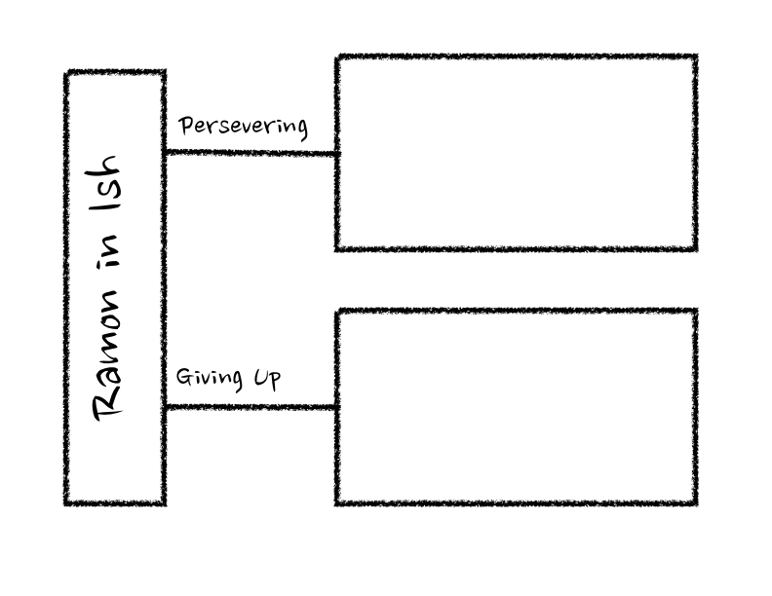

|  |  |
| --- | --- |
| **Lesson 3 – Sky Color by Peter Reynolds**  **Marisol is an artist. She uses her artwork as a way to brighten the lives of others and to share important ideas about social and environmental causes. One day she volunteers to paint the sky on a mural for the library; however, she realizes that she does not have any blue paint. Disappointed, she observes the sky and realizes that the sky has many colors.** | |
| Objective:  After viewing several paintings, students will compare and contrast the differences in artwork in a discussion on a Kahoot presentation on the internet showing five paintings. Then children will work in groups of two or three to compare and contrast two painting; additionally, they will compare the feeling or mood of the painting  After reading the story, Sky Color, children will generate a list of items that are usually predictable colors.  Students will create a painting using non-traditional color choices. After students show their artwork and explain the color and design choices, they will reflect on their ideas about using color to express the mood of the painting.  Time for lesson: Two forty minute segments  Resources:  Sky Color by Peter Reynolds  Materials:   1. Water color paints 2. Water color paper 3. Paint brushes 4. Photographs of a variety of objects | **Activity:**   1. Show children several paintings where the painters used traditional and non-traditional colors. 2. Children will discuss two different paintings in groups of three children. One child will write, one will keep time, and one will speak for the group. 3. Speakers of each group explain how they compared and contrasted the two paintings. 4. Discuss the tendency for people to act on prior ideas rather than being open to new inspiration to express a mood or feeling. 5. Read Sky Color by Peter Reynolds 6. Students will create a chart of items in the world that are usually a predictable color. 7. Students will create a painting using non-traditional colors 8. Students will complete an “Open-Ended Response Form” |
| **Evaluation:** Teacher evaluation on student “Open-Ended Student Response Form” (Karnes & Bean, 2009). A five-point rubric will be used to assess the students’ artwork and response form. See Attachment 2 - Students must obtain a score at the proficient level (3 or above) on all elements. | |

Attachment 1 – Open Ended Response Form

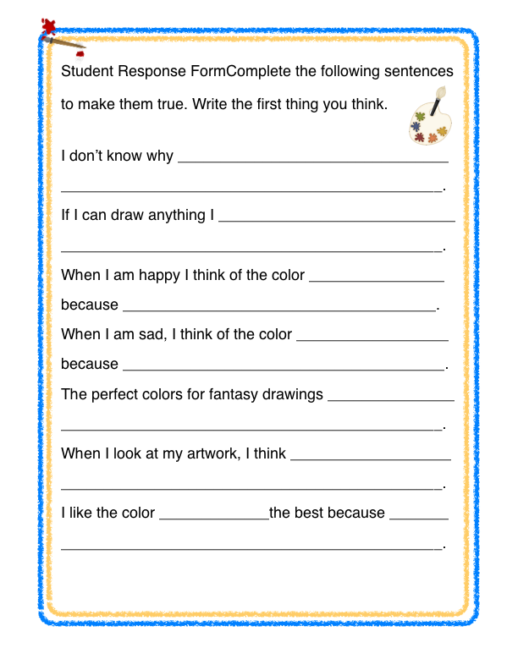Attachment 2 – Rubric

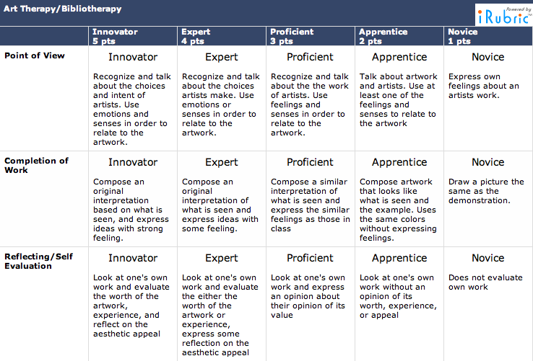References

Blymire, L., Brunner, T., Jones, C., Knauer, D., (1998). *A.C.T. Affective cognitive thinking: Thinking strategies for the gifted.* Harrisburg, PA: Penns Valley Publishers.

Brooks, M. (1986). *Drawing with children: A creative teaching and learning method that words for adults, too.* Los Angeles, CA: Jeremy P. Tarcher, Inc.

Evans, J., Skelton, T. (2001). *How to Teach Art to Children.* Monterrey, CA: Evan Moor Corp.

Imbeau, M. (2011). *Parallel Curriculum Units for Grades K-5.* Thousand Oaks, CA: Corwin.

Karnes, F. A., & Bean, S. M. (2009). *Methods and materials for teaching gifted learners*. Waco, TX: Prufrock Press.

Tomlinson, C.A. (2005). *The differentiated classroom: Responding to the needs of all learners*. Upper Saddle River, NJ: Pearson Education Inc.