Affective Unit: Cinema Therapy Monster’s University

Margaret Tyner

Troy University

Teaching Methods in Gifted Education

EDG6669

|  |  |  |  |
| --- | --- | --- | --- |
| **Affective Unit: Cinematherapy With Monster’s University** | | | |
| Conceptual Lens (Big Idea): **Identity, Challenges, Interdependence** | | | |
| Target Grades: 6 - 9 | | | |
| **Rationale for the Unit:** This unit on the movie Monster’s University (MU) provides opportunities for students to address social and emotional factors influencing motivation, creativity, and success. Cinema therapy provides students with the opportunity to recognize and cultivate behaviors that build confidence, establish healthy social behaviors, expand creativity, and develop self-motivation (Karnes & Bean, 2007). Monster’s University contains several scenes that demonstrate events to bear out the consequences of motivation, effort, creativity, and confidence. The high interest nature of the movie gives students an opportunity to explore their own feelings in a funny and non-threatening format. | | | |
| **Critical Content** | | | |
| **Objectives**  **The students will …** | **Process Skills**  **The students will be able to…** | | **Supporting Concepts** |
| * Define key terms related to intelligence, creativity * Describe ways personality traits, motivation, and physical factors affect performance, creativity, memory, and learning * Recognize asynchronous development * Observe problems from different points of view * Accept mistakes as opportunities to learn * Examine feelings and intuition as important as reason and logic * Evaluate how fantasy and reflection are valuable tools for learning and creative development * Explain how to employ strategies to stick with tasks until they are completed | * Develop a definition of intelligence * Apply decision-making and creative problem-solving strategies * Create explanations of opinions with reasoning to support them * Analyze self evaluation for evidence of strengths using Gardner’s multiple intelligence theory * Discuss points of view * Assess their own mindset, types of intelligence they possess, and preferred learning styles * Develop a personal plan for increasing their emotional, motivational, and physical health * Design, conduct, and evaluate social science experiments * Gather, interpret, and evaluate information * Research and express findings visually, orally, and in writing | | * Sternberg’s theory of intelligence * Gardner’s multiple intelligence theory * Emotional intelligence * Components of creative thinking: fluency, flexibility, originality, elaboration * Memory strategies: chunking, mnemonics, visual images, acronyms * Kohlberg’s Levels of Moral Development * Meyer’s Briggs (MB) Personality Profile |
| **Vocabulary** | | **Disciplines** |
| * Intelligence * Creativity * Personality | * Emotion * Imagination | * Psychologist * Psychiatrist * Counselor |
| **Essential Understandings/Generalizations** | | | | |
| 1. People develop and change because of experiences and emotional responses 2. Emotional, motivational, and physical factors influence intelligence, creativity, memory, and learning. 3. Your emotions, environment, and experiences affect the way you perceive your surroundings and yourself. | | | | |
| **Essential Questions** | | | | |
| 1. How do experiences and emotional responses help people develop and change? 2. How can emotional, motivational, and physical factors influence intelligence, creativity, memory, and learning? 3. How do your emotions, environment, and experience affect your perceptions of your surroundings and yourself? | | | | |

|  |  |
| --- | --- |
| **Alabama Course of Study Standards** | |
| 1. Articulate feelings of competence and confidence as learners (A:A1.1). 2. Accept mistakes as essential to the learning process (A:A1.4). 3. Identify attitudes and behaviors leading to successful learning (A:A1.5). 4. Demonstrate how effort and persistence positively affect learning (A:A2.2). 5. Demonstrate the ability to work independently, as well as the ability to work cooperatively with other students (A:A3.2). 6. Demonstrate dependability, productivity and initiative (A:A3.4). 7. Demonstrate the motivation to achieve individual potential (A:B1.1). 8. Use problem-solving and decision-making skills to assess progress toward educational goals (A:B2.5). 9. Understand how school success and academic achievement enhance future career and vocational opportunities (A:C1.6). 10. Describe the influence of environmental variables, motivation, experience, and expectations on perception (SS 9-12 #4). 11. Identify common sources of stress (SS 9-12 #5). 12. Identify significant contributors and contributions to current understanding of the process of learning (SS 9-12 #8). 13. Describe the interrelationship and importance of thought and language on human behavior (SS 9-12 #9). 14. Describe the role of motivation and emotion in human behavior (SS 9-12 #11). 15. Describe methods of assessing individual differences (SS 9-12 #12). | |
| **Class Activities/Lesson Plans/Evaluation** | |
| **Lesson 1 – Exposition – Introduction of Characters** | |
| Objective: After completing the Meyers Briggs (MB) Personality Profile, students will write about their personality type on a Frayer Chart (Attachment 1). Examples: INFP, INFJ, ENTP  After watching MU a second time, Scenes 1 thorugh 3, students will evaluate the ways personality traits and motivation affect performance, creativity, memory, and learning and judge the personality of at least two main characters by writing in their reflection journals. Then students will contribute ideas to a master character chart to hang somewhere in the room (Sternberg & Grigorenko, 2007). Using the charts, students will discuss the characters’ personality Profiles.  After discussing, comparing, and contrasting the characters’ personality profiles with their own personality and viewing a “Trading Card” of Mike Wazowski (Disney Wiki), students will create a self-portrait on a creative “Trading Card”. One side of the card will depict a self-portrait. On the other side the students will create a list of their own character qualities. | Activity:   1. Take MB Personality Profile 2. Write about personality type by defining each word (Extrovert, Introvert, Sensing, Intuitive, Thinking, Feeling, Judging, Perceiving). 3. Watch MU, Scene 1 through 3 (1st 20 minutes) 4. Discuss the scenes 5. Watch scenes again-write personality profile of main characters 6. Determine personality of two or more of the main characters. Choose two characters. 7. Compare the characters to own personality profile 8. Create a self portrait as a “Monster Card”   Resources:  Monster’s University Scene 1  <http://disney.wikia.com/wiki/Mike_Wazowski>  Materials:  1. Paper  2. Tag Board  3. Colored Pencils  4. Sharpie Pens |
| Evaluation – Students will be graded on the self-portrait with a rubric (Attachment 2). Students must obtain a score at the proficient level (3 or above) on all elements (Creativity/Originality, Personality Profile Development, and Visual Aesthetics/Effort). | |

|  |  |
| --- | --- |
| **Lesson 2 – Character Development and Introduction of Character Flaws** | |
| Objective: After reading a definition of asynchronous development, students will watch Scenes 5 through 7.  After highlighting several quotes, students will discuss the main characters, Mike and Sully in a T chart (Redeeming Qualities/Character Flaws). After showing students a chart of Kohlberg’s Levels of Moral Development, analyze the characters morals related to Kohlberg’s Levels of Moral Development.  Students will prepare a presentation from one option chosen on the choice board (Attachment 3).  Resources:  1. Monster’s University Scene 5 through 7  2. <http://disney>.wikia.com/wiki/Mike_Wazowski  Materials: Choice board | Activity:   1. Watch Scenes 5 through 7 2. Discuss Mike’s and Sully’s asynchronous development in a T chart and talk about their subsequent friendship 3. Show students Kohlberg’s Levels of Moral Development 4. Determine the levels of development of the main characters in selected quotes:    1. On the first day of class    2. After class, in the Dorm 5. Choice board with several options related to objectives (Attachment 3). 6. Students will present their project to the class in a 5-10 minute presentation |
| Evaluation – Students’ presentation and product will be evaluated with a checklist style rubric. Students must obtain a score at the proficient level (3 or above) on all elements. | |

Quotes from the first day of class:

PROFESSOR KNIGHT TO SULLEY - I should’ve known. I expect big things from you.

Sulley reaches his seat and looks back to the professor confidently.

SULLEY - Well, you won’t be disappointed.

A few seconds later,

SULLEY - Hey bub. Could I borrow a pencil? I forgot all my stuff.

Quotes from the scene right after class is over, back in the dorm:

Mike flips to December and marks the date for the final.

MIKE - We flunk that final, we are done. I’m not taking any chances.

Mike goes back to September and crosses out the first day of school.

Quote from when Mike is asked if he wants to go to a party:

Mike is too excited about studying to party.

MIKE - When I’m a scarer, life will be a nonstop party. Stay outta trouble, wild man!

Quotes when Mike and Sulley officially meet:

MIKE - Mike Wazowski.

Mike tries to show Sulley to the door.

Listen, it was quite delightful meeting you and whatever that is, but if you don’t mind I have to study my scaring!

SULLEY - Pssh, you don’t need to study scaring, you just do it.

MIKE - Really? I think there’s a little more to it than that. But hey, thanks for stopping by---

|  |  |
| --- | --- |
| **Lesson 3 -** | |
| Objective: After viewing scenes 9 through 12 where the main characters make mistakes but perservere students will disscuss how to accept mistakes as opportunities to learn, examine feelings and intuition as important as reason and logic  Resources:   1. Monster’s University Scene 9 through 12 2. Article – Storytelling strategies: Monsters university’s scary character arcs (Gulino, 2013).   Materials:  Article – Storytelling strategies: Monsters university’s scary character arcs  Socratic discussion questions,  Checklist (Attachment 4) | **Activity:**   1. View scenes 9 through 12 2. Read Article 3. Two groups of students meet with discussion group 4. Students will conduct Socratic Discussion about failure and how to overcome in spite of defeat, talk about how feelings and intuition facilitates success but not at the expense of reason and logic 5. Switch groups after the main points have been discussed 6. Debriefing after Socratic Discussion |
| **Evaluation:** Teacher evaluation, self-evaluation and peer evaluation on Socratic discussion checklist. Students must obtain a score at the proficient level (3 or above) on all elements | |

Attachment 1

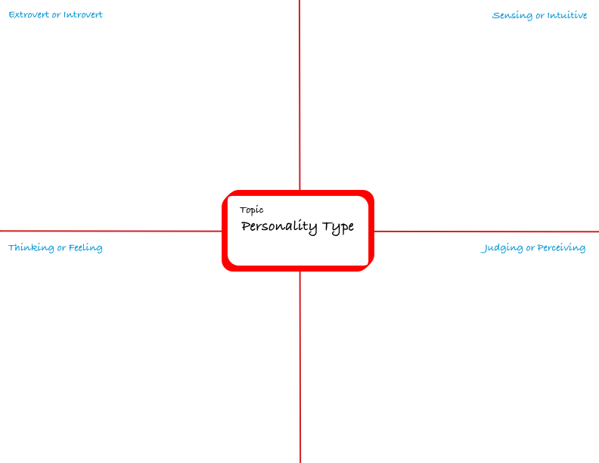

Attachment 2 Rubric

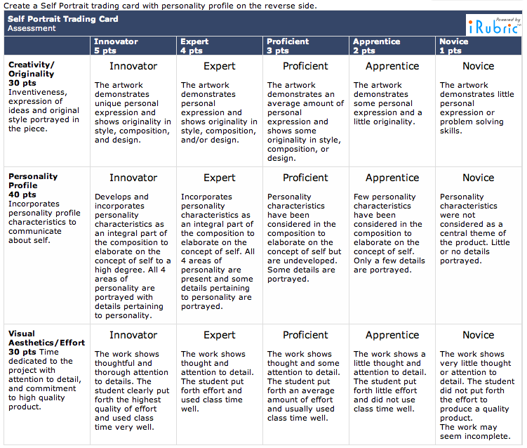

Attachment 3 – Choice Board and Scoring Checklist for Lesson 2

**Monsters’ University Product Criteria Cards**

Choose One of the Following Activities:

|  |  |
| --- | --- |
| Tour Guide Activity  (Create a Map of a Campus)   * Show location of places * Clearly written key and symbols * Has scale and compass rose * Created labels and places on campus * Included distances from locations * Neatness and legibility * Presentation is easy to understand | Brochure with a Logo or Brand for Monsters’ University   * Pictures relate to the topic * Highlights the classes available * Activities for moral/social development * Logo for campus is well designed * Attractive and neat layout * Important points clear * Presentation is easy to understand |
| Scare Game  (Game based on movie or characters)   * Game board looks visually appealing * The characters fit the game * Game has clear, understandable rules * Game is well constructed * Game includes Kohlberg’s Level MD * Neatness and legibility * Presentation is easy to understand | College Application  Monsters’ University   * Formatted correctly * Personal introduction * Spelling and Mechanics are correct * Letter of application is courteous * Letter highlights strengths/weaknesses * Information is focus and well organized * Presentation is easy to understand |

Scoring Criteria for Choice Board:

|  |  |
| --- | --- |
| 5 | Innovative – product creatively and qualitatively exceeds all expectations to the highest degree |
| 4 | Expert – product creatively and qualitatively fulfills all expectations to a high degree |
| 3 | Proficient - product creatively and qualitatively fulfills all expectations |
| 2 | Apprentice – product creatively and qualitatively fulfills most expectations |
| 1 | Novice – product fulfils some expectations |

Attachment 4 (Socratic Circle)

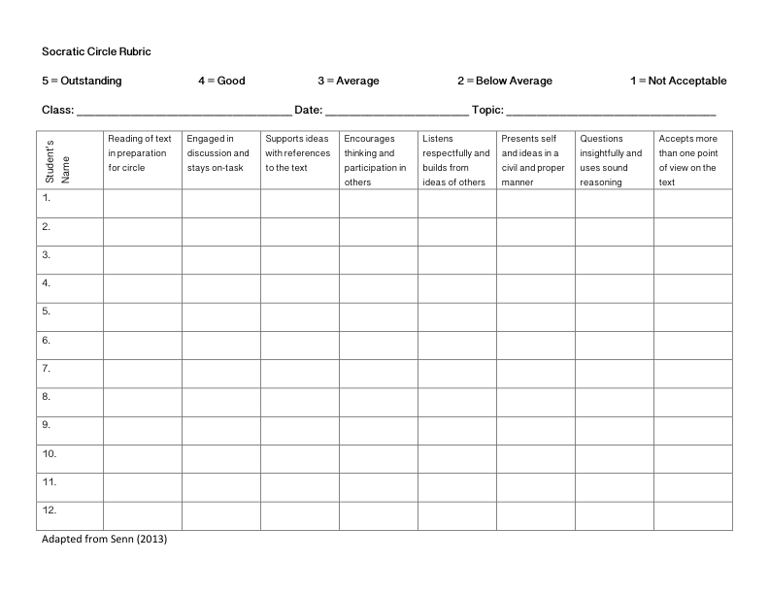Questions:

Part 1 Essential Questions

1. How do experiences and emotional responses help people develop and change?
2. How can emotional, motivational, and physical factors influence intelligence, creativity, memory, and learning?
3. How do your emotions, environment, and experience affect your perceptions of your surroundings and yourself?

Part 2 Core Questions:

1. What are some of the strengths and weaknesses of the main characters in Monsters’ University?
2. How does Mike’s personality balance Sulley’s personality?
3. How did the main characters respond to failure?
4. With which character do you most identify? Why?
5. How does personality type play a role in character qualities and how people respond to success or failure? (Use examples from the movie or from personal experience)
6. On which level of moral development do you think the characters stand?

References

*Coil, C. (2004) Activities and Assessments for the Differentiated Classroom.* Marion IL: Pieces of Learning

*The Disney Wiki: Mike Wazowski.* Retrieved from http://disney.wikia.com/wiki/Mike_Wazowski

Gulino, J. (2013) *Storytelling strategies: Monsters university’s scary character arcs.* Retrieved from <http://www.scriptmag.com/features/storytelling-strategies-monsters-universitys-scary-character-arcs>

Karnes, F. A., & Bean, S. M. (2009). *Methods and materials for teaching gifted learners*. Waco, TX: Prufrock Press.

Scanlon, D., Gerson, D., Baird, R. (2013). *Monster’s University Screen Play.* Retrieved from <http://waltdisneystudiosawards.com/downloads/monsters-university-screenplay.pdf>.

Senn, L. (2013). *Observation of Socratic circle.* October 24, 2013.

Sternberg, R., Grigorenko, E. (2007) *Teaching for successful intelligence: To increase student learning and achievement.* Thousand Oaks, CA: Corwin Press.